IPO CHART
INPUTS | PROCESS | OUTPUT
- First number  - Second number | - Ask the student for the initial number, then record it in num1.  - Ask the student for the second number, then record it in num2.  - Compare the 2 numbers and start with the smaller one  - Reduce the trial factor by 1 until it divide both numbers exactly for a common factor | - Display highest common factor  - Display error if no common factor
Activity 1.2D

flow chart
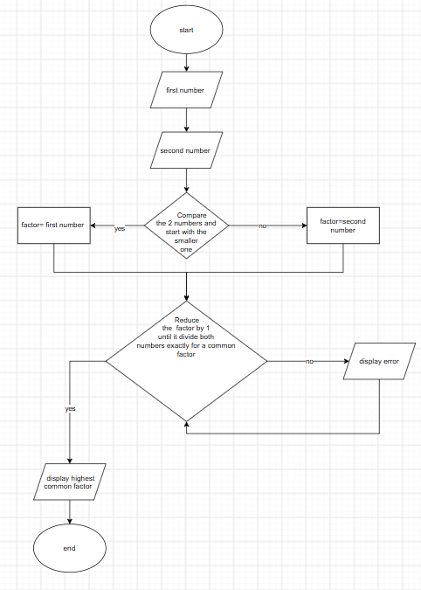

Python code
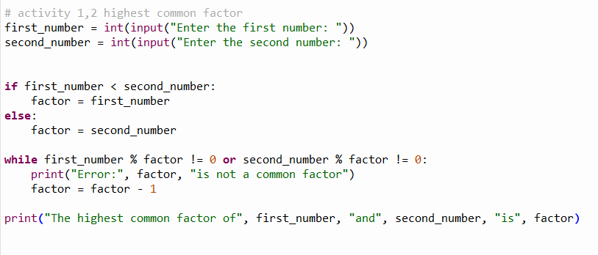
TRACE TABLE
TEST CASE | FIRST_NUMBER | 2ND NUMBER | RESULT
#1 | 5 | 25 | 5
#2 | 6 | 60 | 6
#3 | 7 | 165 | 1

